Navigating Around Webex - Quick Reference Login Guide
When you have logged on via the EPN link information – If it does not take you straight in click
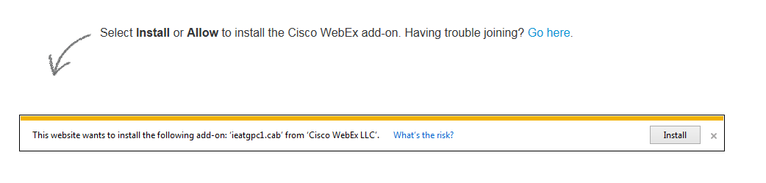
Please then click
Follow this with click here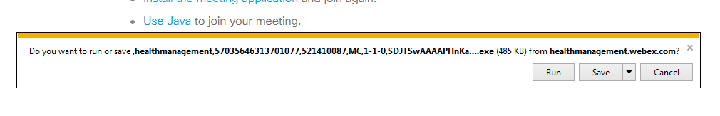
Fully logged on you will see this page
