Below is an example of the accrued benefits and results for a senior manager who was in alpha for the full year with linked final salary benefits in Classic.
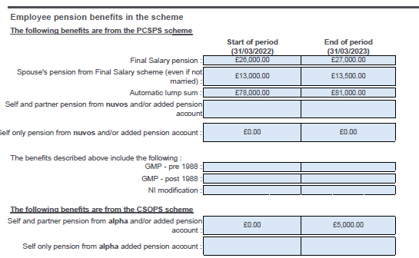
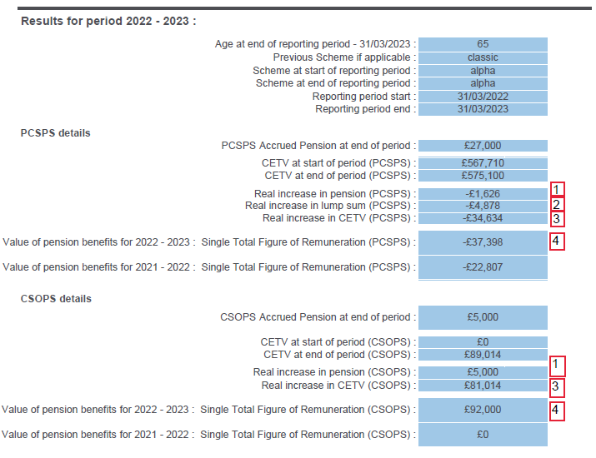

Below are examples of how the real increases are calculated for:
1: Accrued pension (Classic linked benefits and alpha)
2: Lump sum (Classic linked benefits only as no lump sum in alpha)
3: CETV (Classic linked benefits and alpha)
4: Single Total Figure of Remuneration (Classic linked benefits and alpha)

Example 1: Increase in accrued pension where the senior manager was in post for the full year.
Classic:
Accrued pension as at 31 March 2022 (previous year end) | £26,000 (A)
Accrued pension as at 31 March 2023 (current year end) | £27,000 (B)
Accrued pension as at 31 March 2022 (previous year end) plus inflation (@ 10.01%) | £26,000 (A) x 1.101 = £28,626 (C)
Real increase in accrued pension during current financial year | £27,000 (B) - £28,626 (C) = -£1,626 (D)
Alpha:
Accrued pension as at 31 March 2022 (previous year end) | £0.00 (only in alpha from 01.04.2022)
Accrued pension as at 31 March 2023 (current year end) | £5,000
Real increase in accrued pension during current financial year | £5,000
Example 2: Increase in accrued lump sum where the senior manager was in post for the full year.
Classic:
Accrued lump sum as at 31 March 2022 (previous year end) | £78,000 (A)
Accrued lump sum as at 31 March 2023 (current year end) | £81,000 (B)
Accrued lump sum as at 31 March 2022 (previous year end) plus inflation (@ 10.1%) | £78,000 (A) x 1.101 = £85,878 (C)
Real increase in accrued lump sum during current financial year | £81,000 (B) - £85,878 (C) = -£4,878 (D)
Example 3: Increase in CETV where the senior manager was in post for the full year.
Classic:
CETV as at 31 March 2022 (previous year end) | £567,710 (A)
CETV as at 31 March 2023 (current year end) | £575,100 (B)
CETV as at 31 March 2022 (previous year end) plus inflation (@ 10.1% and based on age factors at the end of the year, not shown on the results page) | £567,710 (A) x 1.101 x relevant age factors = £609,733.80 (C)
Real increase in CETV during current financial year | £575,100 (B) - £609,733.80 (C) = - £34,633.80 (D) (rounded to -£34,634)
Alpha:
CETV as at 31 March 2022 (previous year end) | £0.00 (A)
CETV as at 31 March 2023 (current year end) | £89,014 (B)
Contributions paid during the year | £8,000 (C)
Real increase in CETV during current financial year after deductions | £89,014 (B) - £8,000 (C) =-£81,014 (D)
Example 4: Single Total Figure of Remuneration where the senior manager was in post for the full year.
Classic:
Real increase In Pension as at 31 March 2023 | -£1,626 (A)
Real increase In Lump sum as at 31 March 2023 | -£4,878 (B)
Single Total Figure of Remuneration | -£1,626 (A) x 20 + -£4,878 (B) = -£37,398 (C)
Alpha:
Real increase In Pension as at 31 March 2023 | £5,000 (A)
Contributions paid during the year | £8,000 (B)
Single Total Figure of Remuneration | £5,000 (A) x 20 - £8,000 (B) = -£92,000 (C)

